Assignment 11

**Question 1:** Write a JAVA code to detect the mth character of a given string

**Code:**

class test

{

public static void main(String args[])

{

String str="Programming" ;

System.out.println("string = " + str);

int len=str.length();

System.out.println(len);

char a_char = str.charAt(3);

System.out.println("character at index 3 is : "+a_char);

char ar_char = str.charAt(5);

System.out.println("character at index 5 is : "+ar_char);

}

}

**Output:**

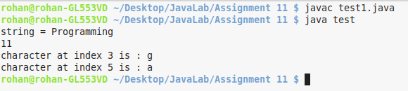

**Question 2:** Write a JAVA program to sort n strings in lexicographical order

**Code:**

import java.util.Scanner;

class test

{

public static void main(String[] args)

{

int n;

String temp;

Scanner s = new Scanner(System.in);

System.out.print("Enter number of names you want to enter:");

n = s.nextInt();

String names[] = new String[n];

Scanner s1 = new Scanner(System.in);

System.out.println("Enter all the names:");

for(int i = 0; i < n; i++)

{

names[i] = s1.nextLine();

}

for (int i = 0; i < (n-1); i++)

{

for (int j = i + 1; j < n; j++)

{

if (names[i].compareTo(names[j])>0)

{

temp = names[i];

names[i] = names[j];

names[j] = temp;

}

}

}

System.out.println("Names in Sorted Order:");

for (int i = 0; i < n ; i++)

{

System.out.println(names[i]);

}

}

}

**Output:**

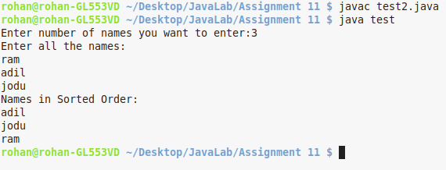

**Question 3:** Write a JAVA program to generate the histogram of a given word

**Code:**

import java.util.Scanner;

class test

{

public static void main(String[] args)

{

Scanner kb = new Scanner(System.in);

final int LETTERS_IN_ALPHABET = 26;

int[] letterCounter = new int[LETTERS_IN_ALPHABET];

System.out.print("Enter string: ");

String string = kb.nextLine();

for(int i = 0; i < string.length(); i++){

char letterThere = string.charAt(i);

int placeInLetterCtr = whereInLetterCtr(letterThere);

letterCounter[placeInLetterCtr]++;

}

printNumbers(letterCounter);

printLetters();

}

public static int whereInLetterCtr(char letter){

int i =0 ;

for(char comparisonLetter = 'a'; comparisonLetter <= 'z'; comparisonLetter++){

if(letter == comparisonLetter){

return i;

}

i++;

}

return i;

}

public static void printNumbers(int[] array){

for(int i=0; i<array.length; i++){

System.out.printf("%4d", array[i]);

}

System.out.println();

}

public static void printLetters(){

for(char letter ='a'; letter <='z'; letter++){

System.out.printf("%4c", letter);

}

System.out.println();

}

}

**Output:**

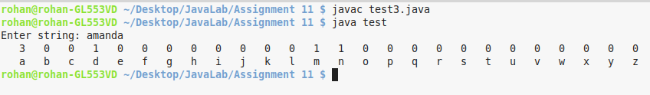

**Question 4:** Write a java program to print odd and even numbers using two separate threads (First thread is created by Thread class and the Second thread is created by Runnable interface)

**Code:**

class Odd extends Thread

{

public void run()

{

for(int i=1;i<10;i=i+2)

{

System.out.println(i);

try {Thread.sleep(1000);}

catch(Exception e){}

}

}

}

class Even implements Runnable

{

public void run()

{

for(int i=2;i<=10;i=i+2)

{

System.out.println(i);

try {Thread.sleep(1000);}

catch(Exception e){}

}

}

}

class test

{

public static void main(String args[])

{

Odd obj1 = new Odd();

Runnable obj2= new Even();

Thread t = new Thread(obj2);

obj1.start();

try {Thread.sleep(10);}

catch(Exception e){}

t.start();

}

}

**Output:**

